## Index

|  |  |  |
| --- | --- | --- |
| Sr no. | Title | Page no. |
| 1. | Introduction |  |
|  | 1.1 Company profile | 1 |
|  | 1.2 Project profile | 2 |
| 2. | System specification |  |
|  | 2.1 Scope | 3 |
|  | 2.2 Objective | 3 |
|  | 2.3 Constraints |  |
|  | 2.3.1 Software Constraints | 3 |
|  | 2.4 Advantages | 3 |
|  | 2.5 Limitations | 3 |
| 3. | Environment Designs |  |
|  | 3.1 Hardware and Software Requirements | 4 |
|  | 3.2 Development Description | 4 |
| 4. | System planning |  |
|  | 4.1 Feasibility Study | 5 |
|  | 4.2 Timeline Chart | 6 |
| 5. | System Analysis |  |
|  | 5.1 Detailed SRS | 7 |
|  | 5.2 UML Diagrams |  |
|  | 5.2.1 Use case Diagram | 8 |
|  | 5.2.2 Sequence Diagram | 11 |
|  | 5.2.3 Class Diagram | 14 |
|  | 6. Interface Design | 19 |
|  | 6.1 Screenshots |  |
| 7. | Future Enhancement | 31 |
| 8. | Bibliography | 30 |

## Introduction:

## 1.1 Company Profile

Ignite Infosys achieves that success with its scrolling mischief, powerful imagery and story and creative typography. Where Innovation meets Design in Web Development Miracles are seen! We deploy the right solutions for your business by offering best in class e- Commerce, Web Design, Software Development, Graphic Design, Mobile Application and Integration Services. Whether you are a small business trying to build an online presence or an established one looking for significant improvements. We are the PARTNER for your success. We design, build and implement custom Web and e-commerce Solutions for business, serving a wide variety of clients in different industries from Paper to Pump.

1. Ecommerce Solution: – From shopping cart solutions to third party integrations, we have got you covered.
2. Web Application: – From initial concept to completion, engaging solutions that will streamline your business**.**
3. Responsive Web Design: – We create responsive websites that adapts to various devices and those that get responses.
4. Mobile Application: – Engaging that enhance user experience. Mobile is not another screen, it’s another market.

Our Mission: – To provide cost effective, timely and technology driven end- to-end Web Solutions to grow and enhance with every project.

## Our Vision: –To Create and Think Forward giving complete Web Design Solutions; to help grow your Brand and Business in the Market.

Our Goal: – To be among the top Web Development companies serving clients around the world, round the clock, thereby maintaining long-term relationship with them.

Contact no: +91 9054320918

[Email ID: igniteinfosys@gmail.com](mailto:Email%20ID:%20igniteinfosys@gmail.com)

Website**:** [**www.igniteinfosys.com**](http://www.igniteinfosys.com)

**1.2 Project Profile**

Project Title : Just For Foodies

Group Members : Jaguwala Harsh Ajaybhai(117)

College : J.P. Dawer Institute of Information Science and Technology

Company Name : Ignite Infosys, Surat.

External Guide : Mr. sunil Mishtry

Internal Guide : Dr. Pushpal Desai

|  |  |  |
| --- | --- | --- |
| Software Configuration | :- |  |
| Front End | : | Angular |
| Back End | : | Asp.Net |
| Operating System | : | Microsoft Windows |
| Language | : | Asp.Net,Bootstrap,html,Angular |
| Database Server | : | IIS Server |
| Development Environment | : | Asp.Net,Angular |

## System Specification

## 2.1 Scope

The Restaurant point of sale includes: Sales Order , Reservation. This system will change the manual system of the business in order for the user to work easier and provide faster reservation for the customer.

**2.2 Objective:**

Customer can Online Reservation.

It is easy to use and easy to understand.

Customer data will found very fast either for updating or deleting.

Manager can show datalist of the stock

Message via Email.

**2.3 Constraints**

**2.3.1Software Constraints:**

Any web browser .

Internet Connection Required.

**2.4 Advantages**

User Can easily Booking a Table.

User can use the facilities online

**2.5 Limitations:**

Payment and delivery not done Yet.

Internet Connection is required.

## 3.Environment Specification

**3.1 Hardware & Software Requirements**

|  |  |
| --- | --- |
| Processor | P4/Dual Core or Higher Frequency Processor |
| Hard Disc | 50 GB or Higher |
| RAM | 4 GB or Higher |
| Key Board | Microsoft Slim Key Board |
| Mouse | Microsoft Optical Mouse |
| Monitor | CRT, LCD, TFT (anyone can use) |

**3.2 Development description:**

Software Requirements (for Development):

Asp.net

IIS

## Operating System (for Development):

Microsoft Windows

## 4..System Planning

**4.1 Feasibility Study**

A feasibility study is an evaluation and analysis of the potential of the proposed project which is based on extensive investigation and research to give full comfort to the decisions makers.

## Technical feasibility:

A large part of determining resources has to do with assessing technical feasibility. It considers the technical requirements of the proposed project. The technical requirements are then compared to the technical capability of the organization. The systems project is considered technically feasible if the internal technical capability is sufficient to support the project requirements.

## Operational feasibility:

Operational feasibility is dependent on human resources available for the project and involves projecting whether the system will be used if it is developed and implemented.

Operational feasibility is a measure of how well a proposed system solves the problems and takes advantage of the opportunities identified during scope definition and how it satisfies the requirements identified in the requirements analysis phase of system development.

## Economic feasibility:

As development tools and software are already we own, there isn’t any burden of buying them. The organization doesn’t have the same system, so it is certainly required for them. So here we do not need to invest extra funds to develop the system. Thus, it is economically feasible to the organization.

## Time Schedule feasibility:

Projects are initiated with specific deadline. We need to evaluate whether the deadlines are mandatory or desirable. Time is the one of the critical factor in the development of any system but this kind of feasibility is hardly perfect in any system.

We have been asked to complete the project within the working days of the organization having period of 3 months approximately. So, we have managed to complete the project before given deadline. In the project planning section, we elaborate our ideas to develop the system within the given period.

**4. 2 Timeline Chart**

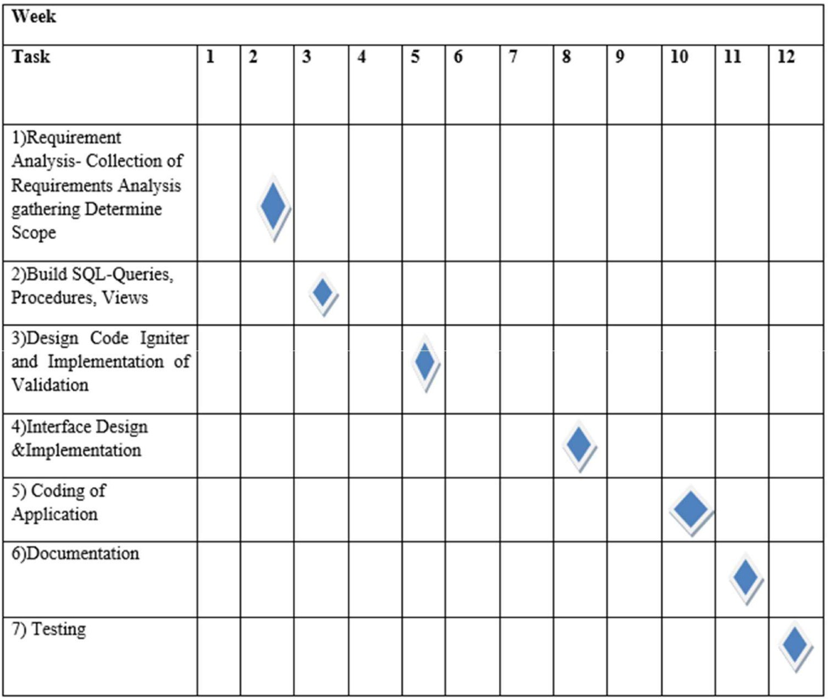

**5.System Analysis**

**5.1 Detailed SRS**

The purpose of SRS is to write the functional and non-functional system requirements that represent the characteristic of Restaurant point of sale.

This system must be designed as Employee required. So, the complete requirement must be found.

**Features**

**Admin:**

Admin can add,edit,delete and view category.

Admin can add,edit,delete and view Items.

Admin can add,edit,delete and view user.

Admin can add,edit,delete and view Menu.

Admin can add,edit,delete and view Purchase.

Admin can add,edit,delete and view Supplier.

Admin can view Order.

Admin can Show Reservation.

Admin can show customer.

Admin can show booking.

**Manager:**

Manager can login using email and password.

Manager can view Employee.

Manager can Add Order.

Manager can View Order.

Manager can Add Category and Show Category.

Manager can Add item and Show Item.

Manager can show Stock list.

Manager can show sales reports and purchase reports.

**Client(userside):**

Customer:

Customer can Add a reservation.

Customer can show Menu

**5.2 UMl Diagrams**

**5.2.1 Use Case Diagram**

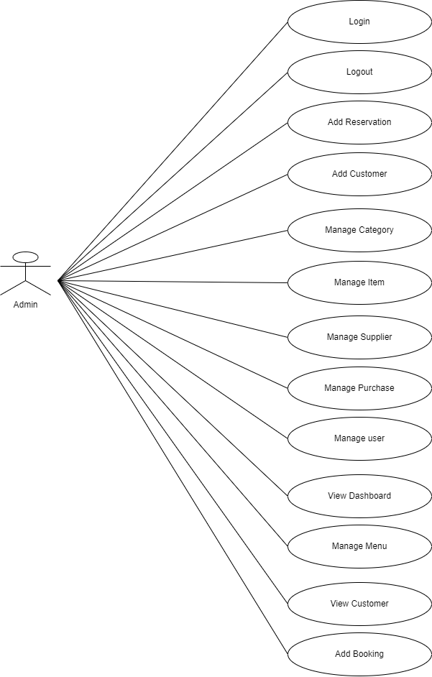

**Manager:**

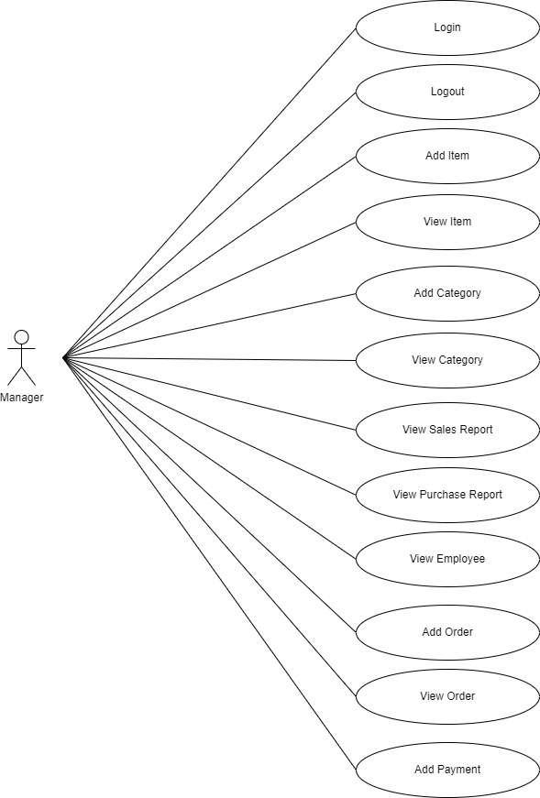

**Client(customer):**

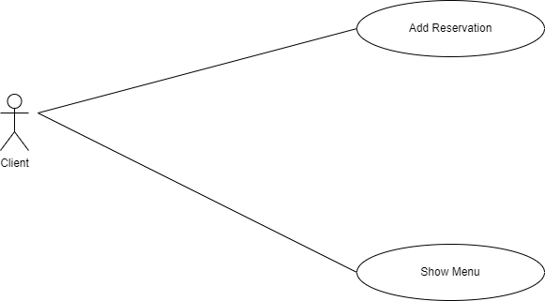

**5.2.2 Sequence Diagrams:**

**Admin:**

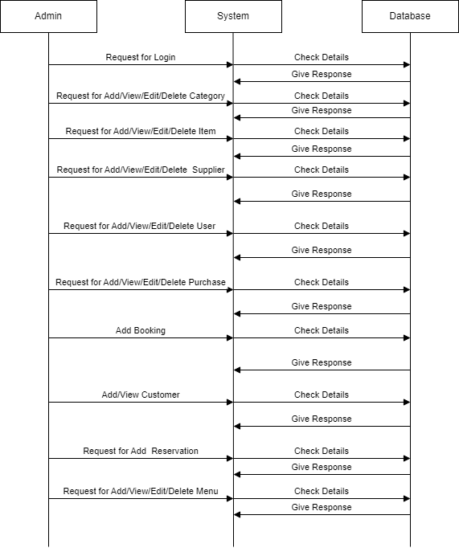

**Manager:**

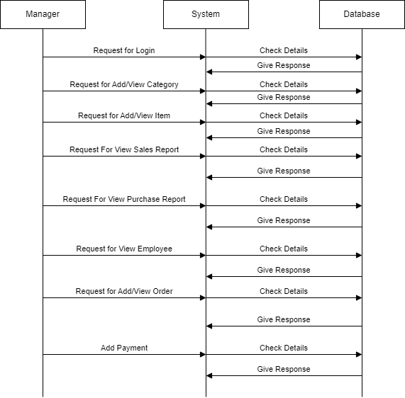

**Client(Customer)**

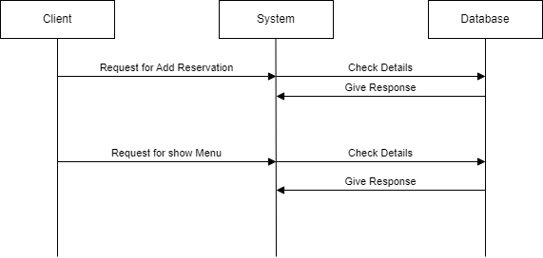

**5.2.3 Class Diagram:**

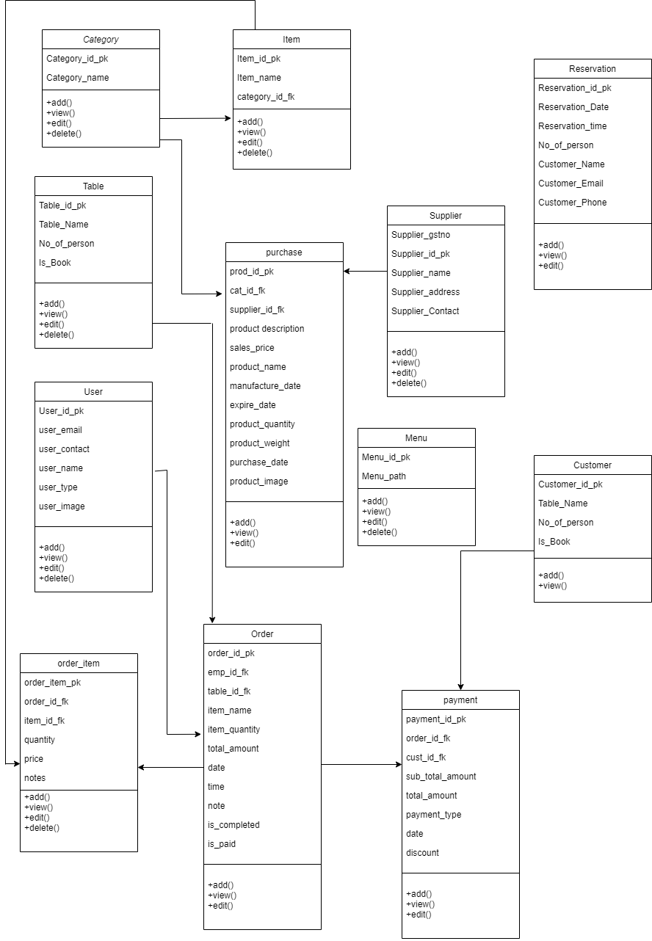

**5.3 Database Design:**

Table name : Category

|  |  |  |  |
| --- | --- | --- | --- |
| Element name | Element description | Data types | Constraint |
| Category_id | Category id | Int | Primary key |
| Category_name | Name of category | varchar | NOT NULL |

Table name : Table

|  |  |  |  |
| --- | --- | --- | --- |
| Element name | Element description | Data types | Constraint |
| Table_id | Id of table | Int | Primary key |
| Table_name | Name of the table | Varchar | Not Null |
| No_of_person | The number of person | Int | Not Null |
| Is_book | To check the table is book or not | Int | Not Null |

Table name : user

|  |  |  |  |
| --- | --- | --- | --- |
| Element name | Element description | Data types | Constraint |
| User_id | Id of user | Int | Primary key |
| User_email | Email of the user | Varchar | Not Null |
| User_Contact | Contact no of user | Int | Not NULL |
| User_name | Name of the user | Varchar | Not Null |
| User_password | Password of the user | Varchar | Not Null |
| User_type | Roll of the user | Varchar | Not Null |
| User_image | Image of the user | Varchar | Not Null |

Table name : supplier

|  |  |  |  |
| --- | --- | --- | --- |
| Element name | Element description | Data types | Constraint |
| Supplier_id | Id of the supplier | Int | Primary key |
| Supplier_name | Name of the supplier | Varchar | Not Null |
| Supplier_gstno | Gstno | Int | Not Null |
| Supplier_address | Address of the supplier | Varchar | Not Null |
| Supplier_contact | Contact no of the supplier | Int | Not Null |

Table name : purchase

|  |  |  |  |
| --- | --- | --- | --- |
| Element name | Element description | Data types | Constraint |
| Prod_id | Id of product | Int | Primary key |
| Cat_id | Id of category | Int | Foreign key |
| Supplier_id | Id of supplier | Int | Foreign key |
| Product_description | Description of product | Varchar | Not Null |
| Purchase_price | Price of the product | Int | Not Null |
| Sales_price | Price of sale | Int | Not Null |
| Prod_name | Name of the product | Varchar | Not Null |
| Manufacture_Date | Manufacture date of product | Date | Not Null |
| Expire_Date | Expire date of product | Date | Not Null |
| Prod_quantity | Quantity of product | Int | Not Null |
| Prod_weight | Weight of the product | Int | Not Null |
| Purchase_date | Which date to be purchased | Varchar | Not Null |
| Prod_image | Image of product | Int | Not Null |
| Is_tax | Tax is applied | Int | Not Null |

Table name : customer

|  |  |  |  |
| --- | --- | --- | --- |
| Element name | Element description | Data types | Constraint |
| Cust_id | Id of customer | Int | Primary key |
| Cust_name | Name of the customer | Varchar | Not Null |
| Cust_email | Name of customer email | Varchar | Not Null |
| Cust_contact | Contact number of the customer | Int | Not Null |

Table name : booking

|  |  |  |  |
| --- | --- | --- | --- |
| Element name | Element description | Data types | Constraint |
| Booking_id | Id of booking | Int | Primary key |
| Table_id | Id of table | Int | Foreign key |
| Cust_id | Id of customer | Int | Foreign key |
| Book_date | Date of the booking | Date | Not Null |
| Book_time | Time of the booking | Time | Not Null |
| No_of_person | No of person | Int | Not Null |

Table name : order

|  |  |  |  |
| --- | --- | --- | --- |
| Element name | Element description | Data types | Constraint |
| Order_id | Id of order | Int | Primary key |
| Emp_id | Id of emp | Int | Foreign key |
| Table_id | Id of table | Int | Foreign key |
| Total_amount | Amount of order | Int | Not Null |
| Date | Date | Date | Not Null |
| Time | Time | Time | Not Null |
| Note | Note of order | Varchar | Not Null |

Table name : payment

|  |  |  |  |
| --- | --- | --- | --- |
| Element name | Element description | Data types | Constraint |
| Payment_id | Id of payment | Int | Primary key |
| Order_id | Id of order | Int | Foreign key |
| Cust_id | Id of customer | Int | Foreign key |
| Sub_total_amt | Sub total amount | Int | Not Null |
| Total_amt | Total amount | Int | Not Null |
| Payment_type | Type of payment | Varchar | Not Null |
| Date | Date | Date | Not Null |
| Discount | Discount of order | Int | Not Null |

Table name:item

|  |  |  |  |
| --- | --- | --- | --- |
| Element name | Element description | Data types | Constraint |
| Item_id | Id of item | Int | Primary key |
| Cat_id | Id of category | Int | Foreign key |
| Item_name | Name of the item | Varchar | Not Null |
| Is_kitchen | Check that is is kitchen | Int | Not Null |
| Item_price | Price of the item | Int | Not Null |
| Item_image | Image of item | Varchar | Not Null |

Table name : order_item

|  |  |  |  |
| --- | --- | --- | --- |
| Element name | Element description | Data types | Constraint |
| Order_item_id | Id of order_item | Int | Primary key |
| Order_id_fk | Id of order | Int | Foreign key |
| Item_id_fk | Foreign key of item | Varchar | Foreign key |
| quantity | Quantity | Int | Not Null |
| price | Price | Int | Not Null |
| Notes | Notes | Varchar | Not Null |

Table name : Menu

|  |  |  |  |
| --- | --- | --- | --- |
| Element name | Element description | Data types | Constraint |
| Menu_id | Menu id | Int | Primary key |
| Menu_Name | Name of Menu | varchar | NOT NULL |

Table name:Reservation

|  |  |  |  |
| --- | --- | --- | --- |
| Element name | Element description | Data types | Constraint |
| Reservation_id | Id of Reservation | Int | Primary key |
| Reservation_date | Date or reservation | varchar | Not Null |
| Reservation_Time | Time of the Reservation | Varchar | Not Null |
| Customer_Name | Name of the customer | Varchar | Not Null |
| Customer_email | Email of the customer | Varchar | Not Null |
| Customer_phone | Phone no of the customer | Int | Not Null |

**6.Interface Design**

**Admin:**

**Login**

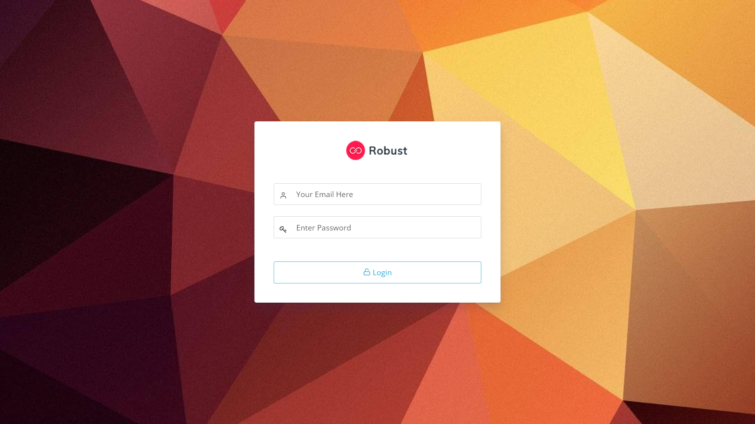

**Dashboard**

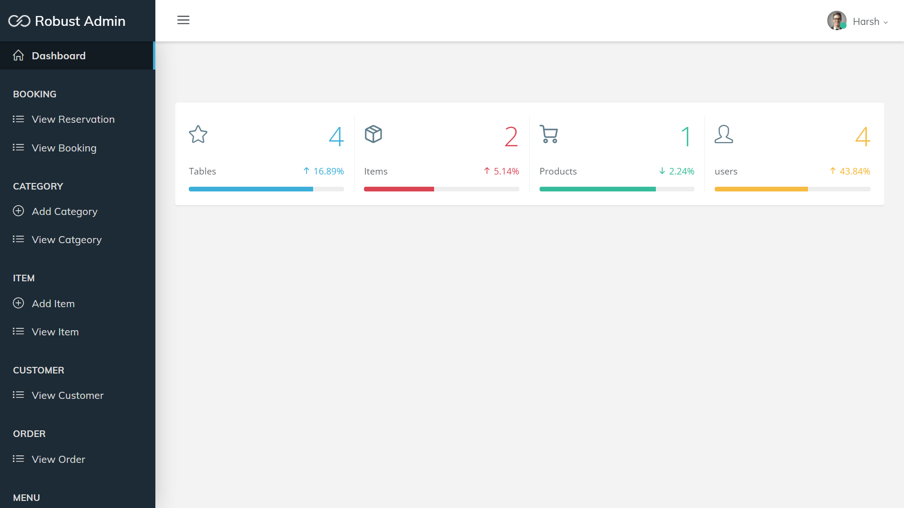

**View Reservation**

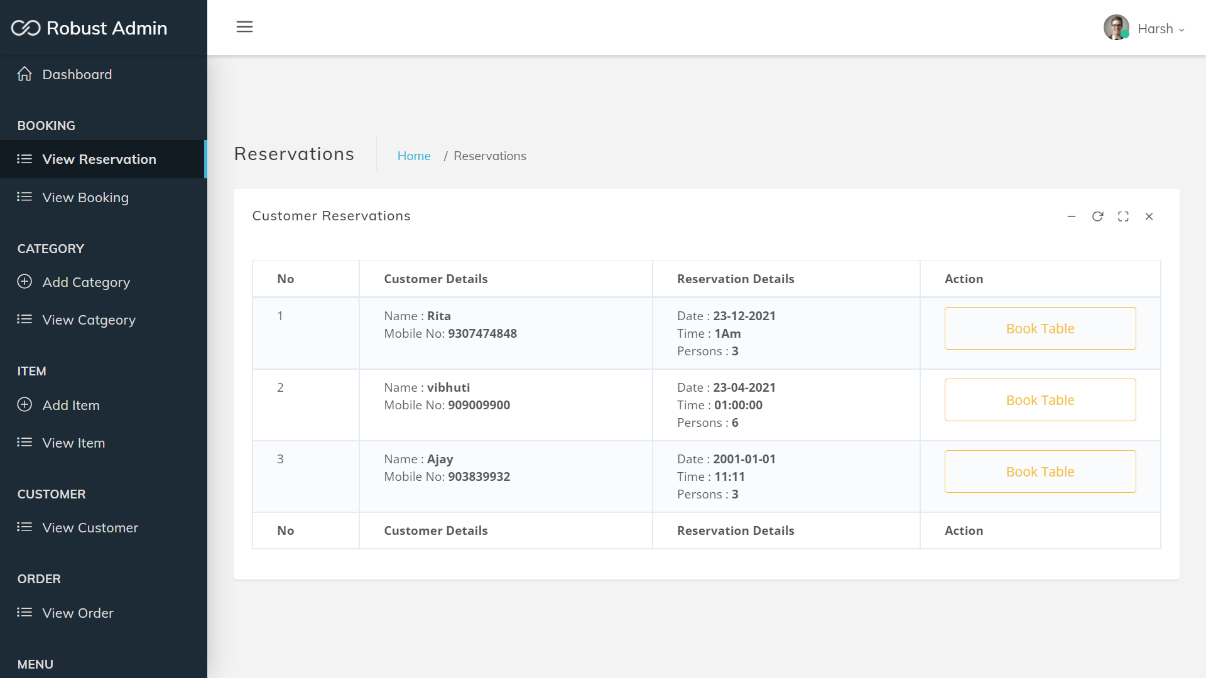

**Add Category**

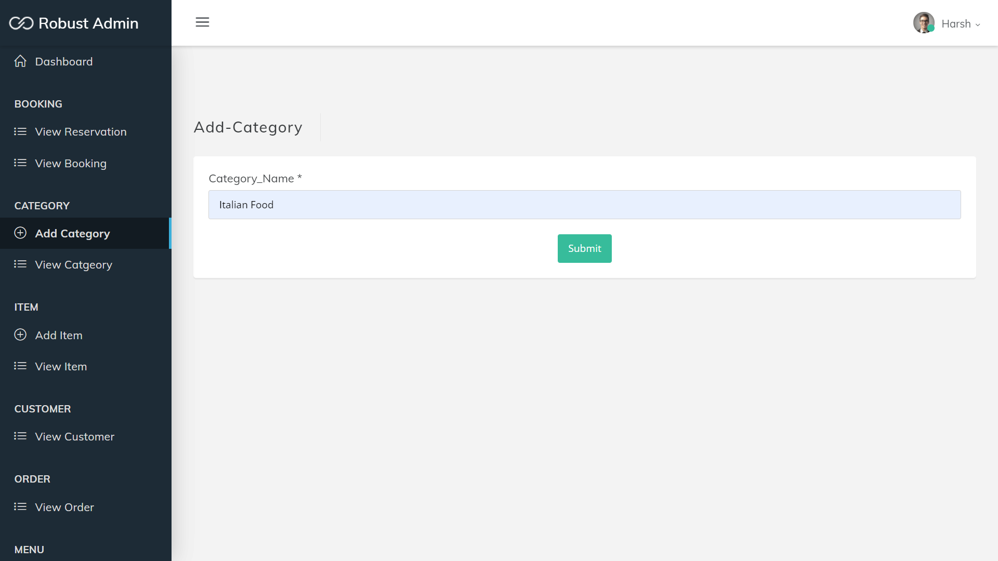

**Show Category**

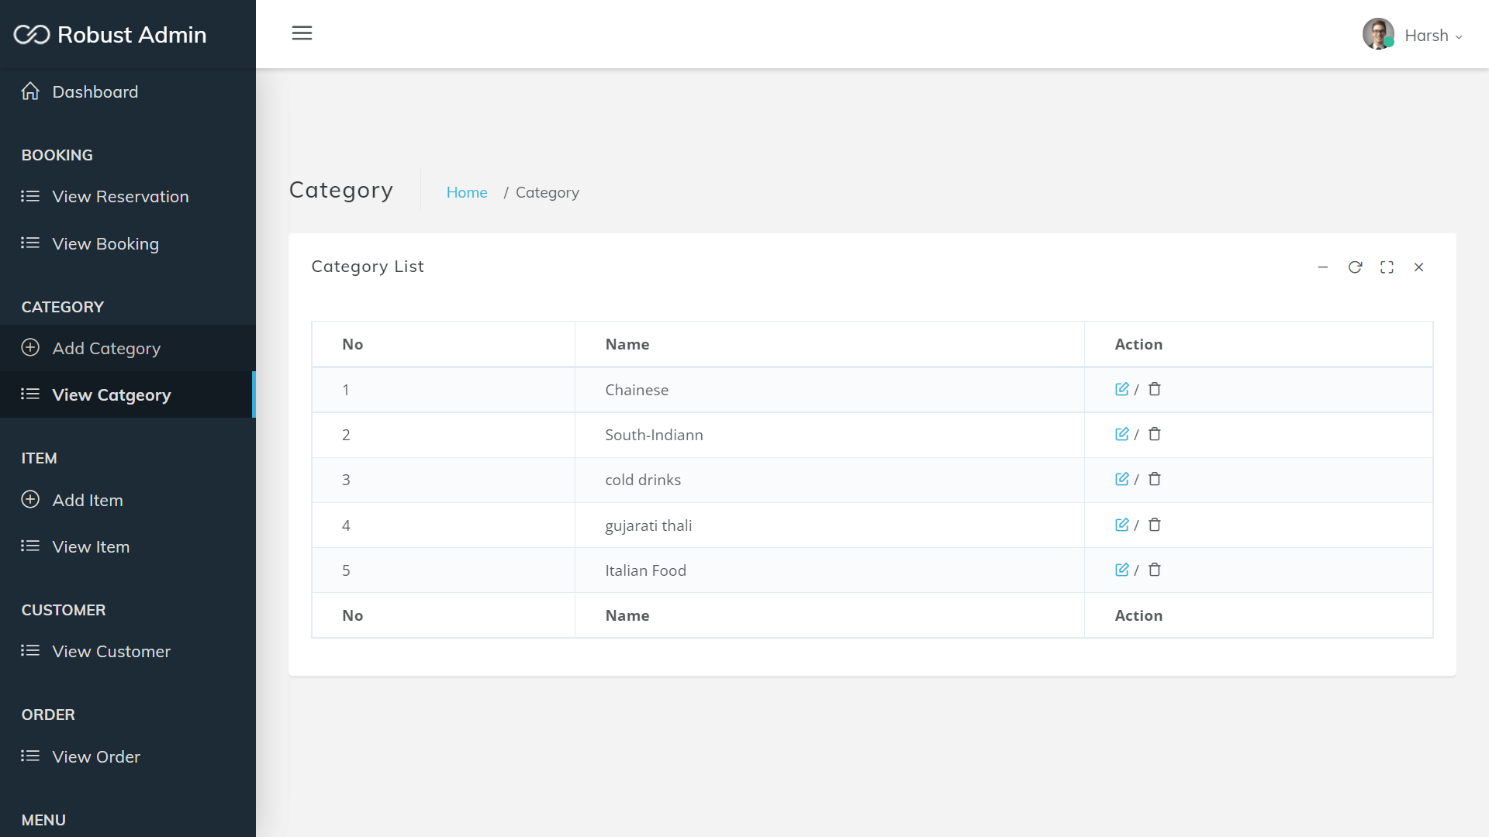

**Add Item**

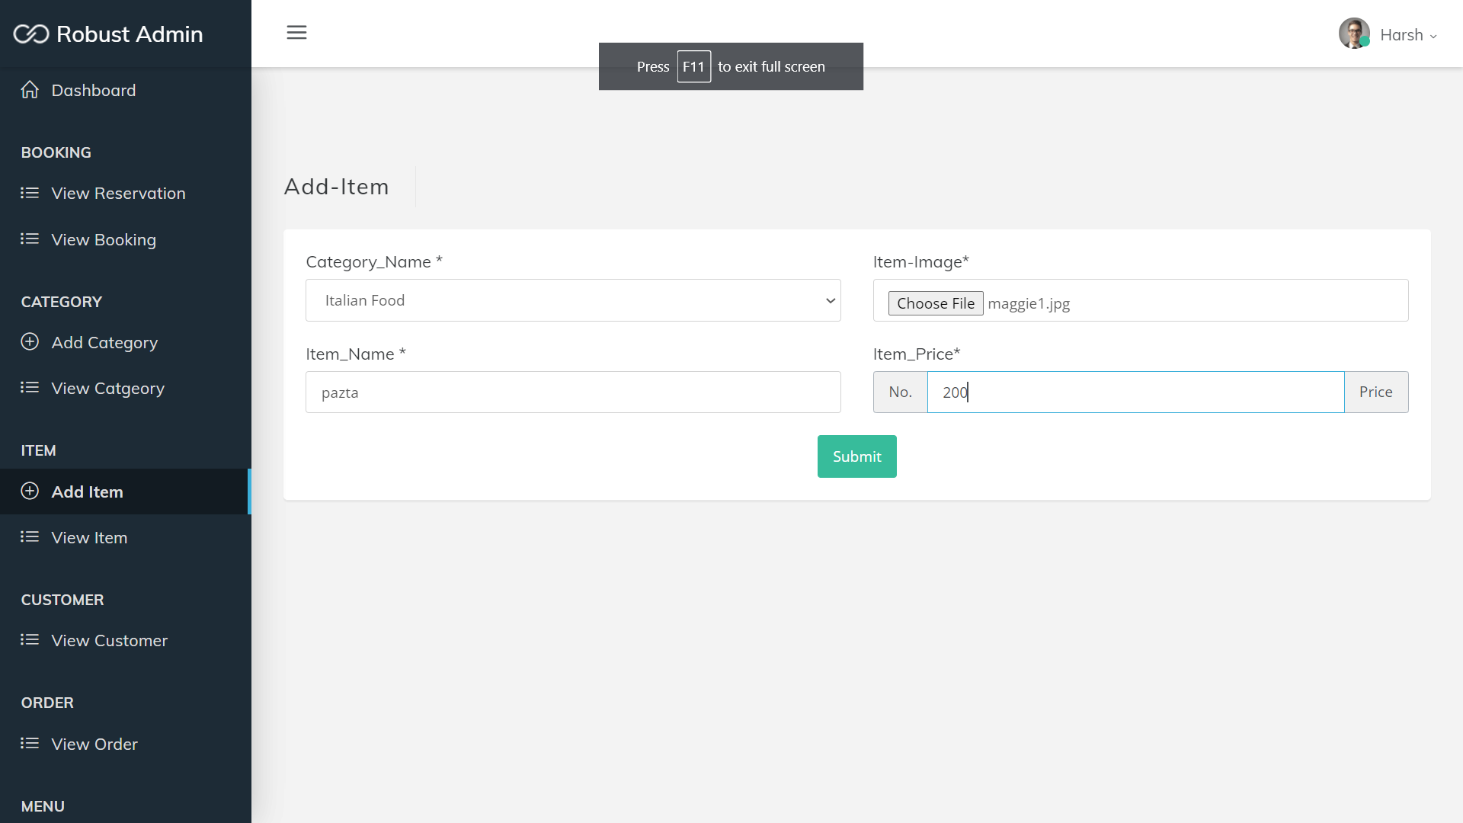

**Show Item**

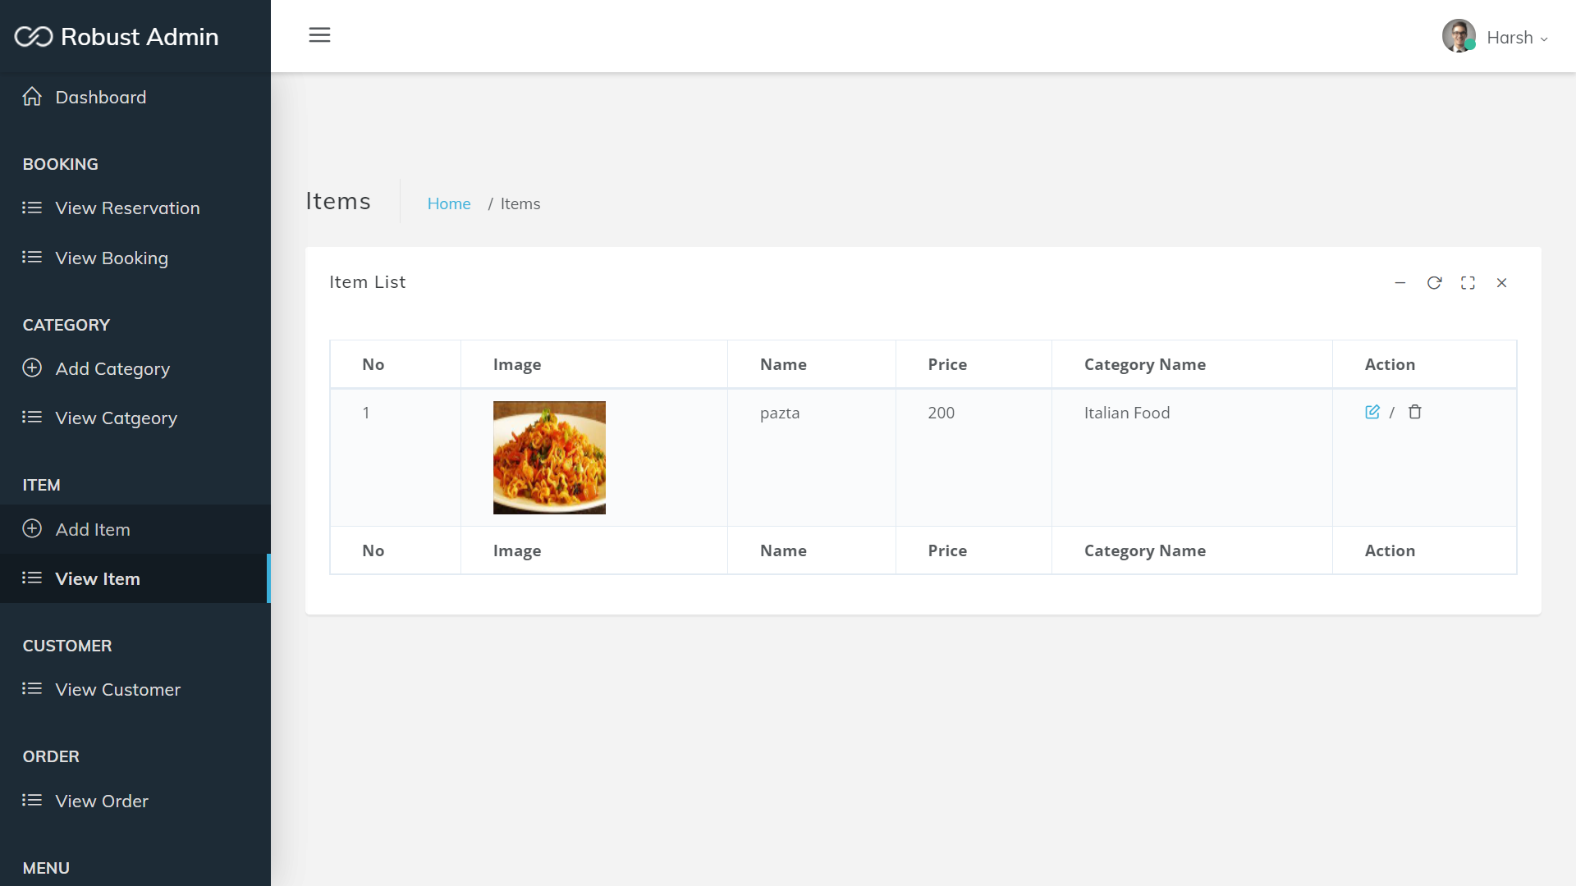

**View Customer**

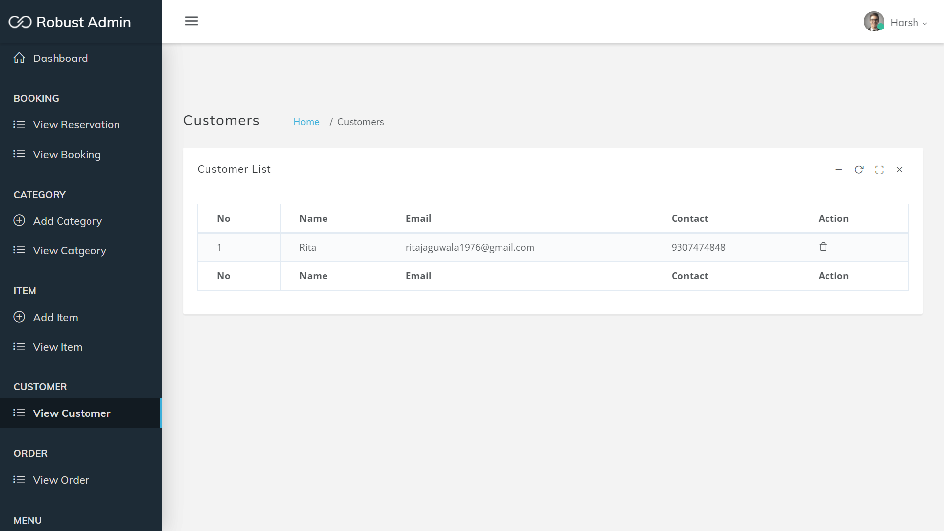

**Add user**

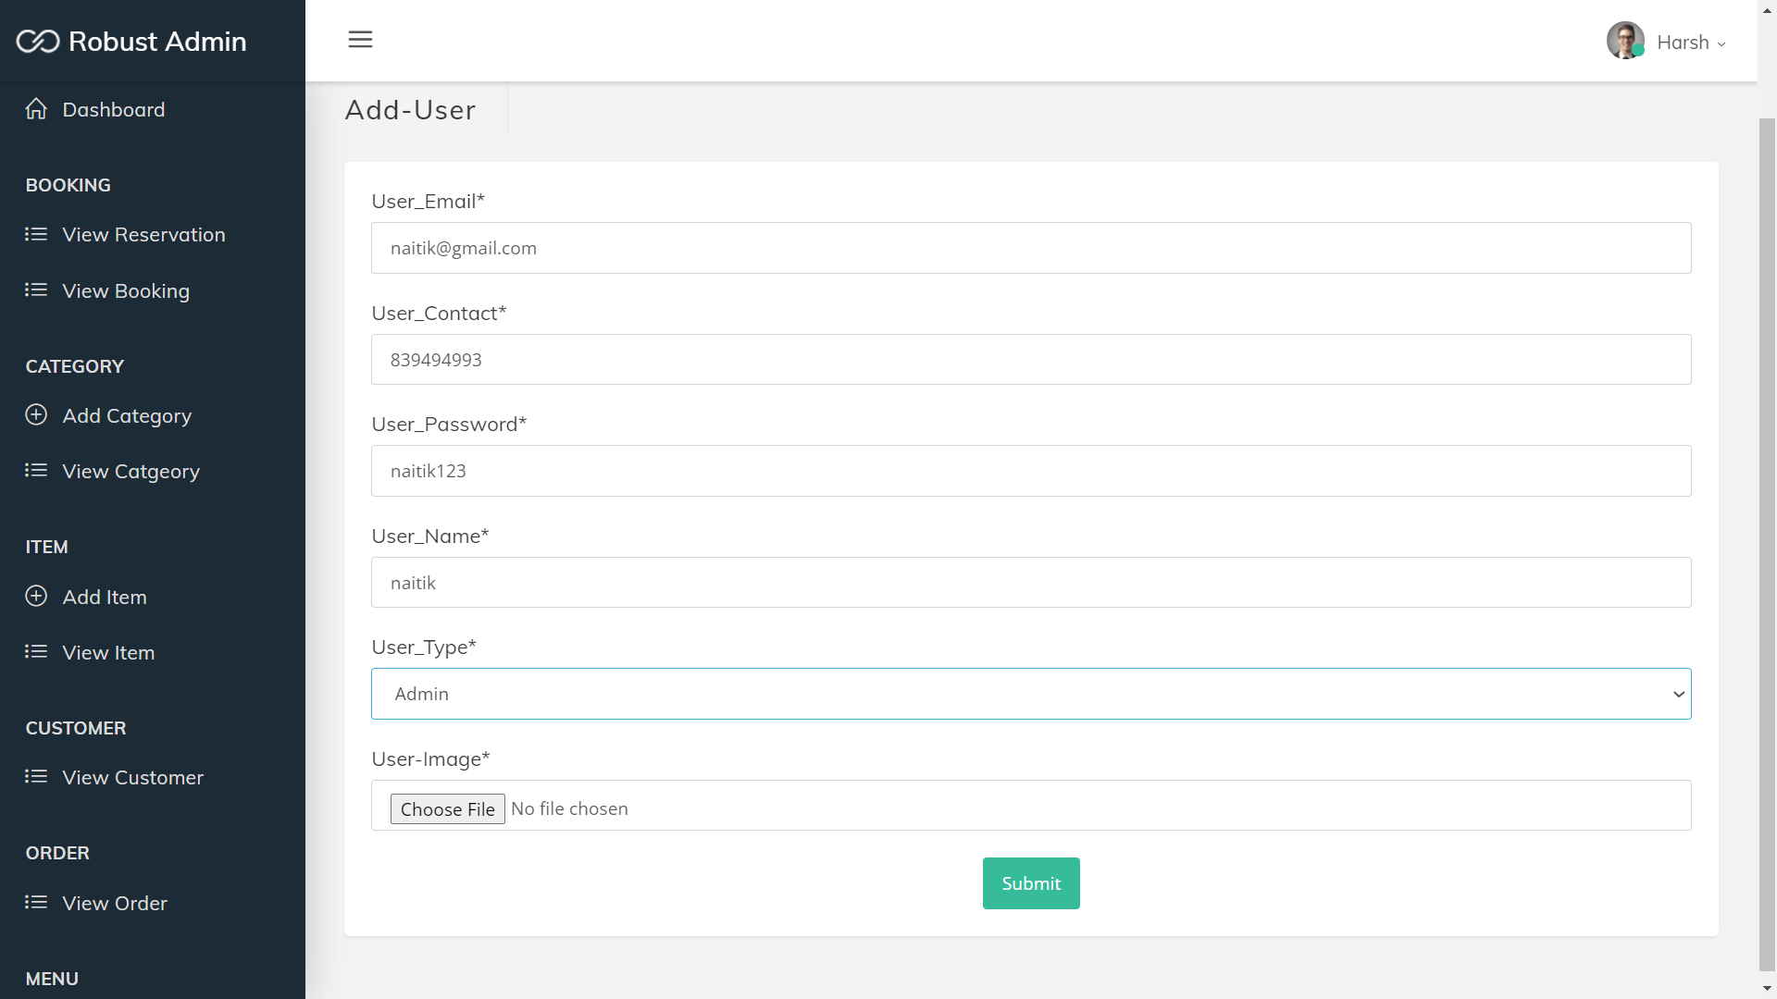

**View User**

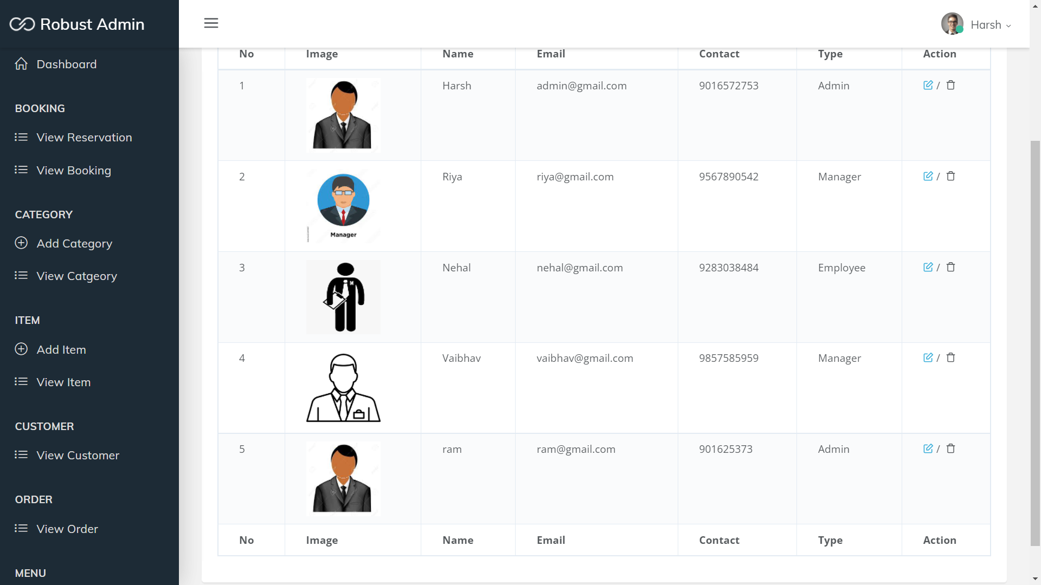

**Add-Menu**

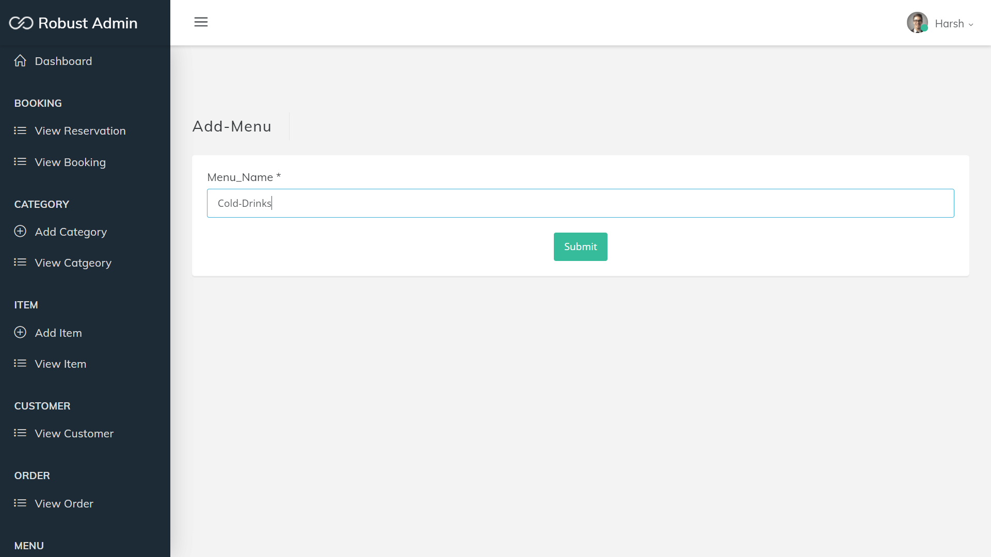

**Show-Menu**

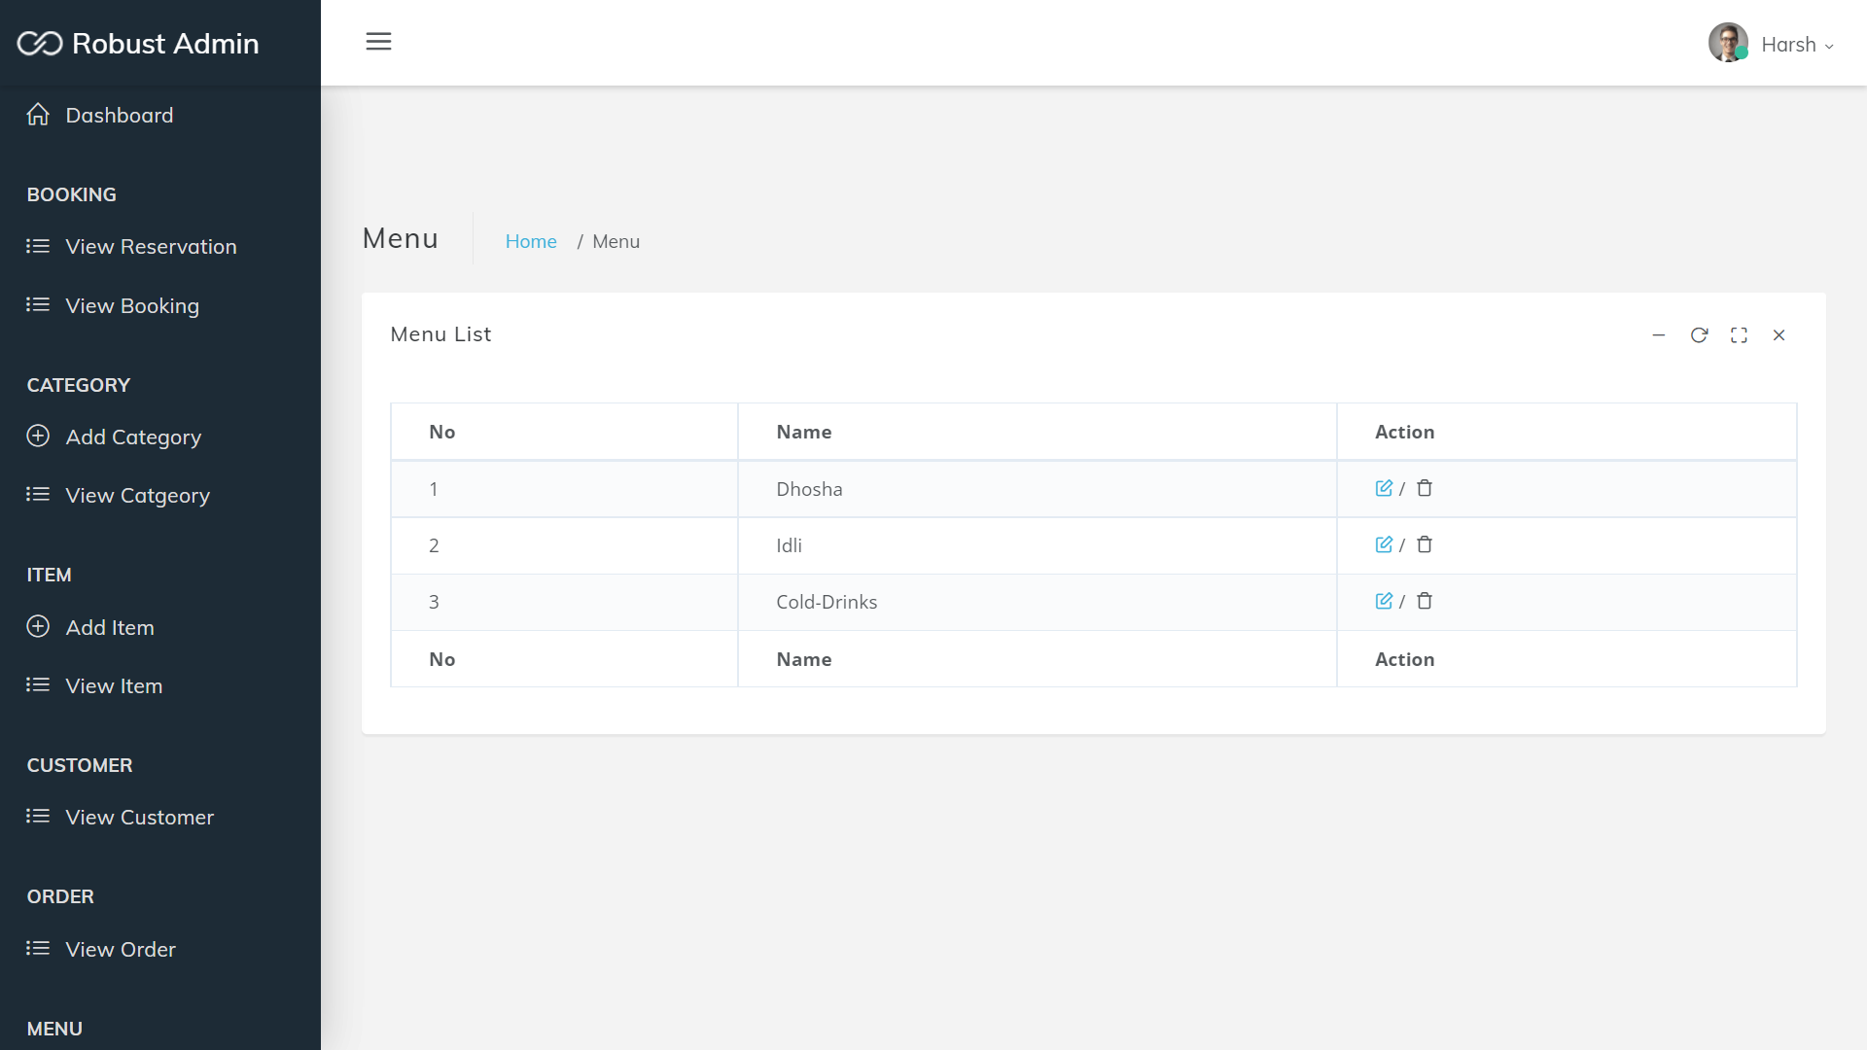

**View order**

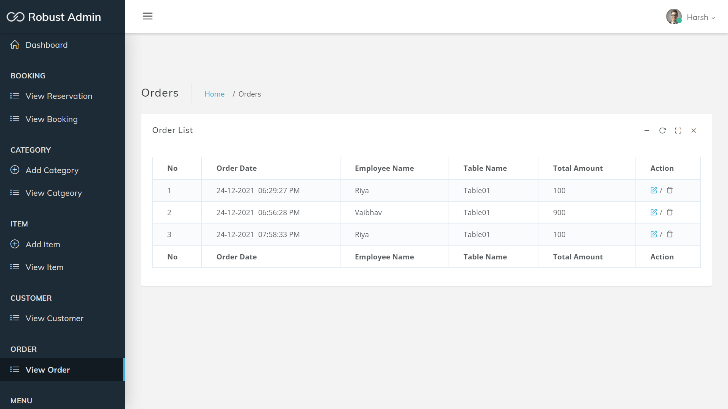

**Show-payment**

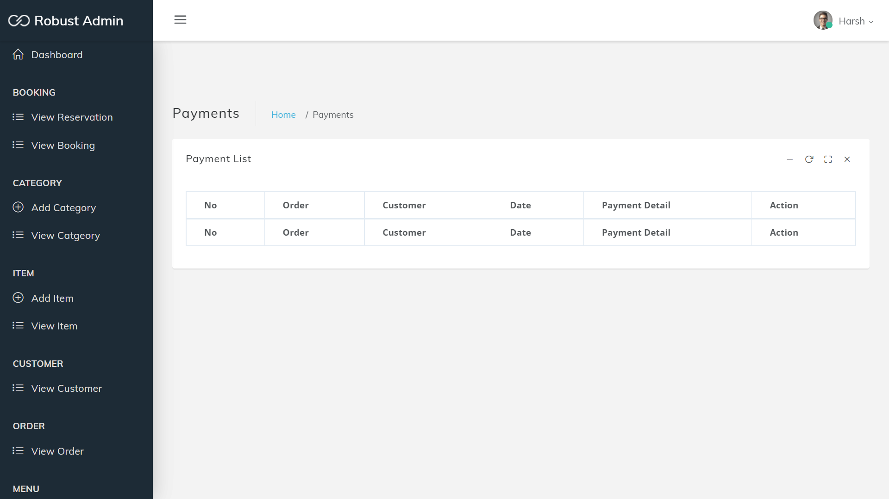

**Manager:**

**Dashboard**

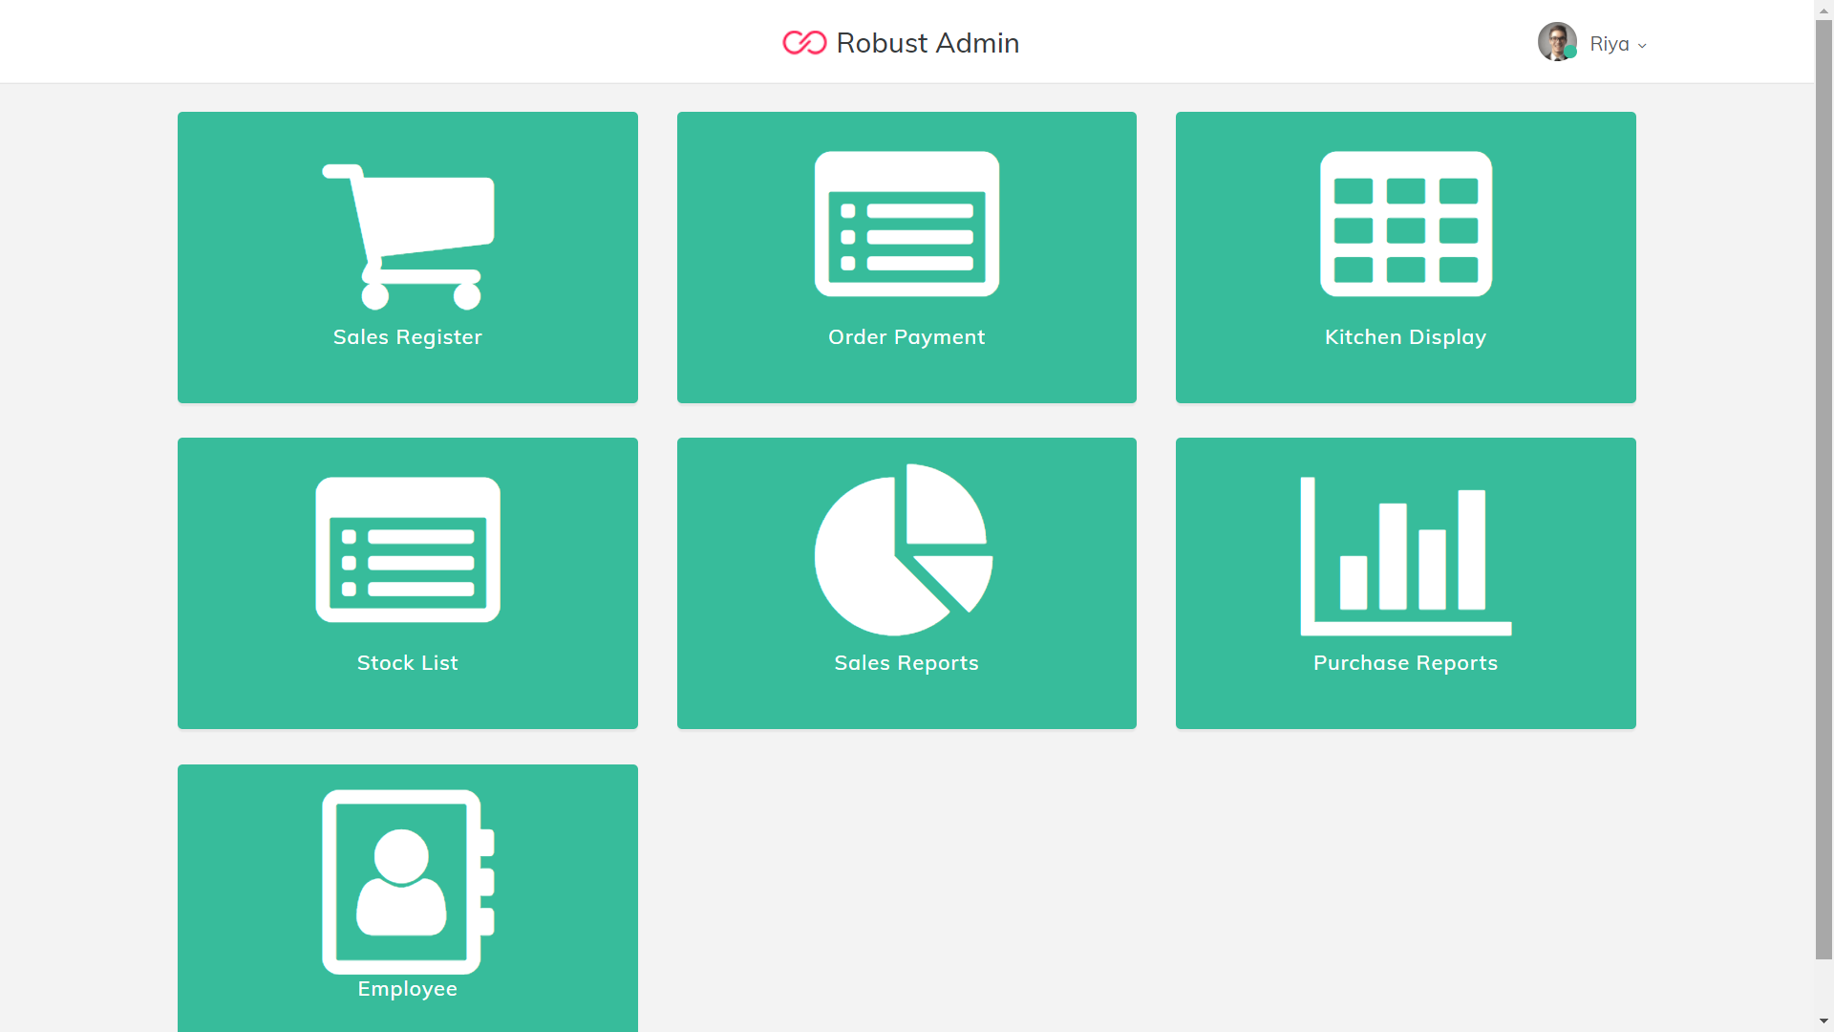

**Take order**

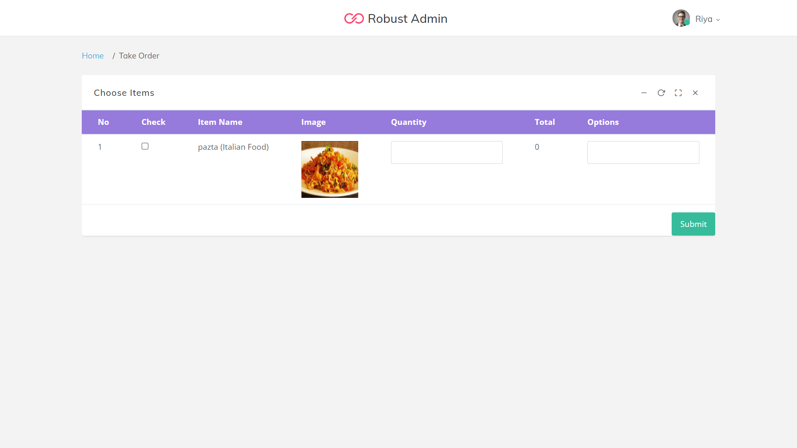

**Show Order**

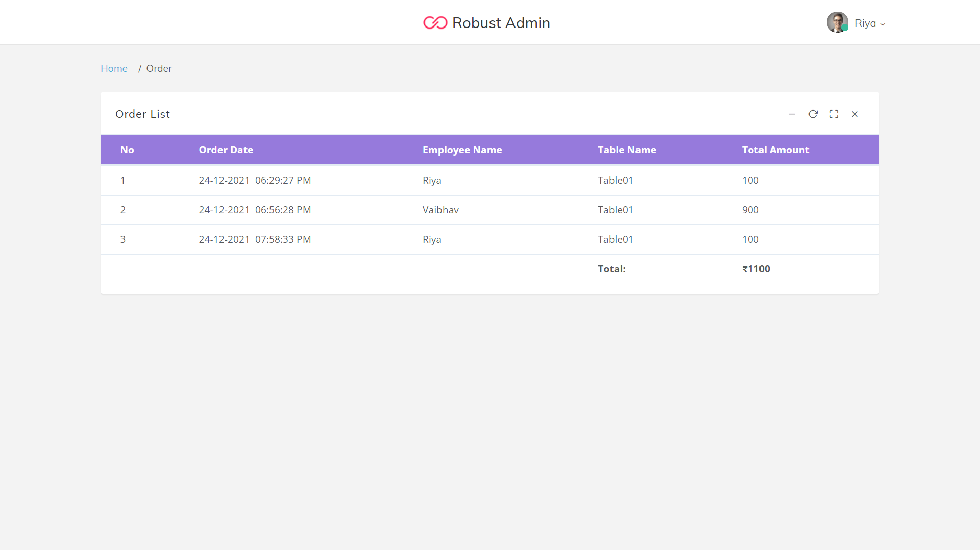

**Add-Item**

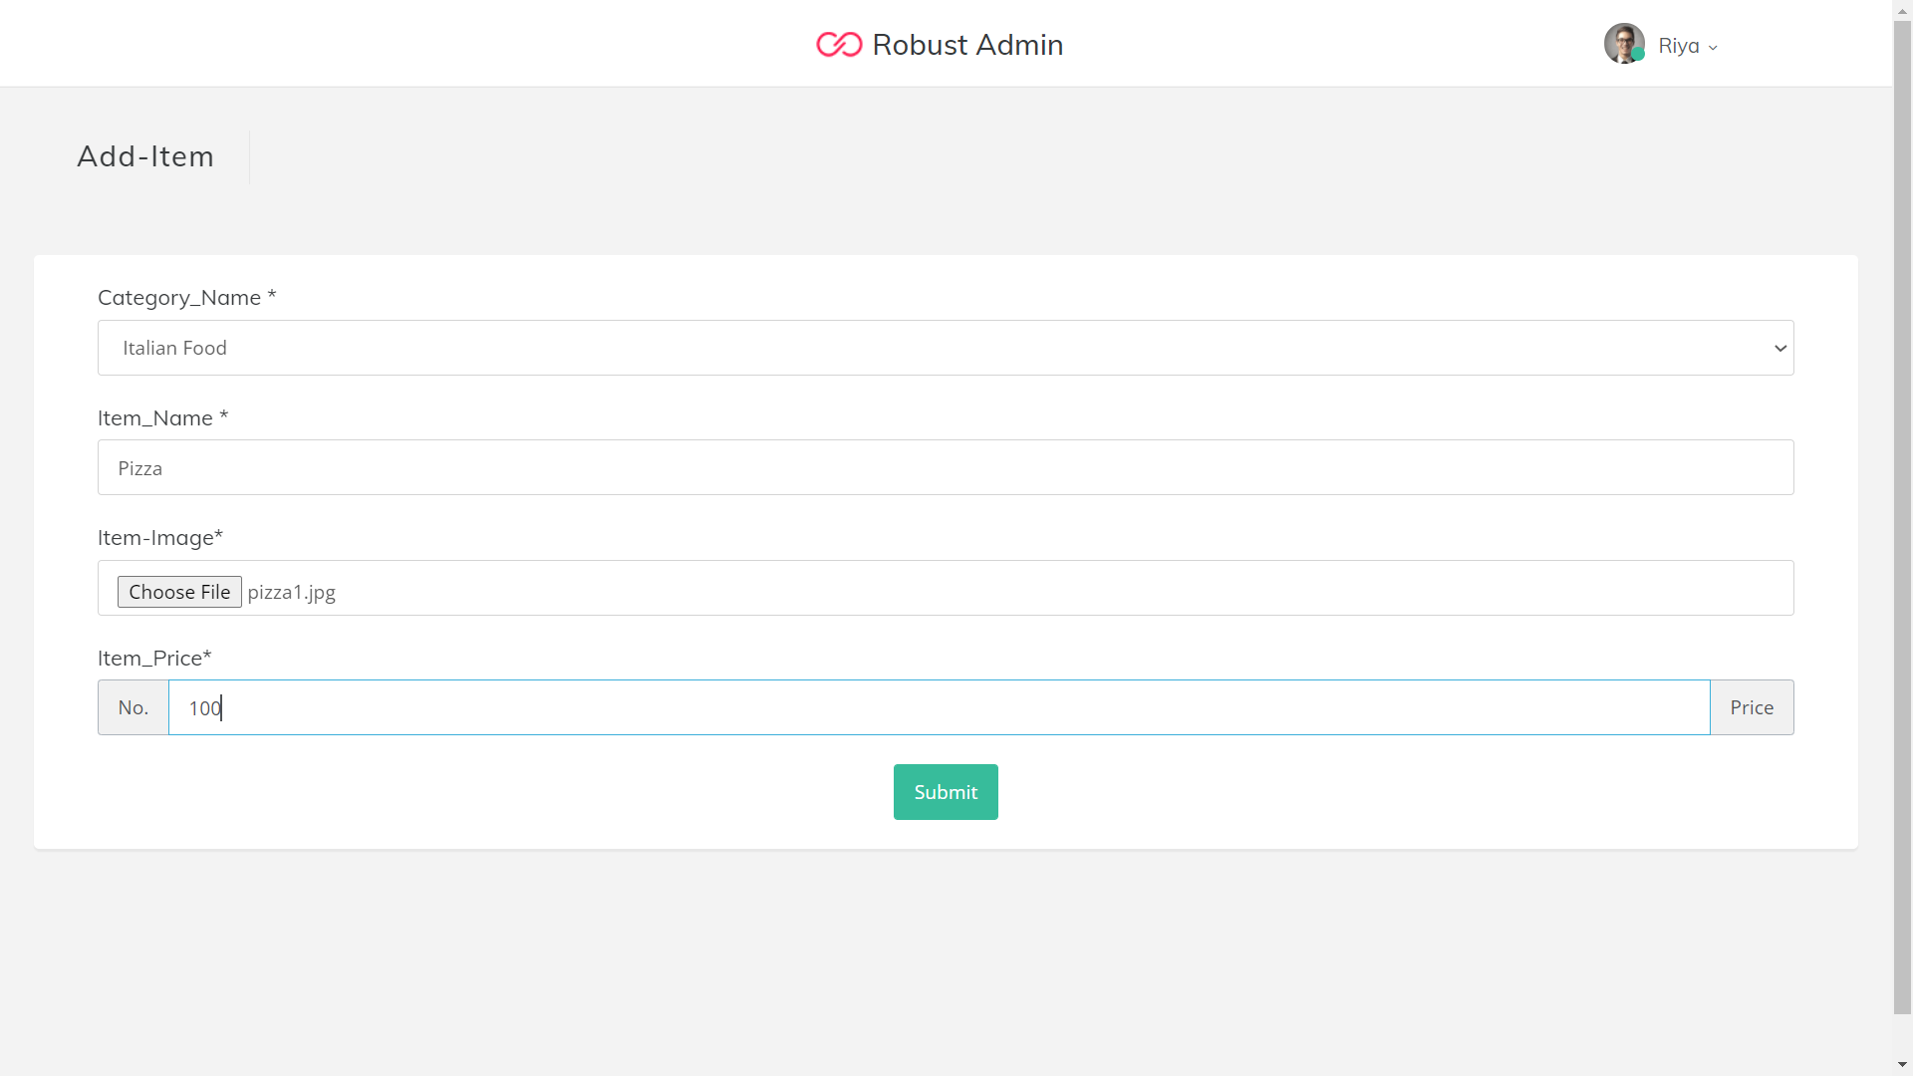

**Show-item**

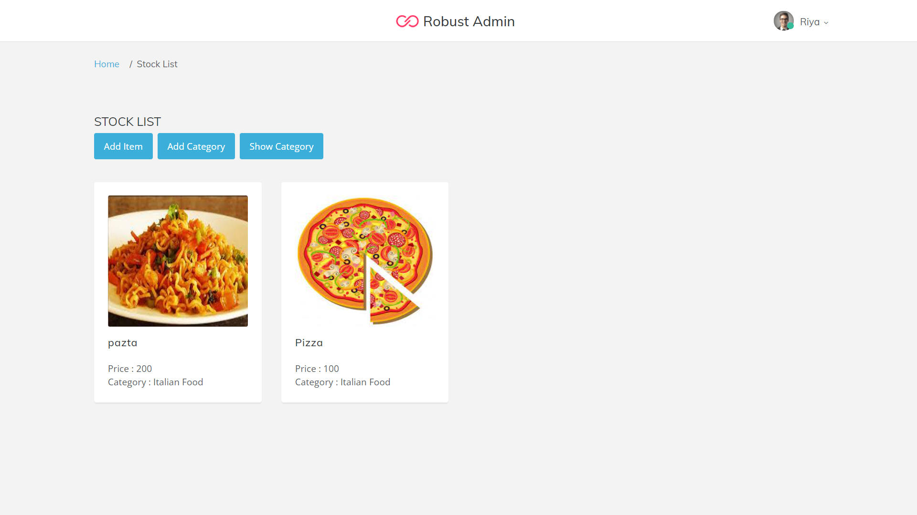

**Add-Category**

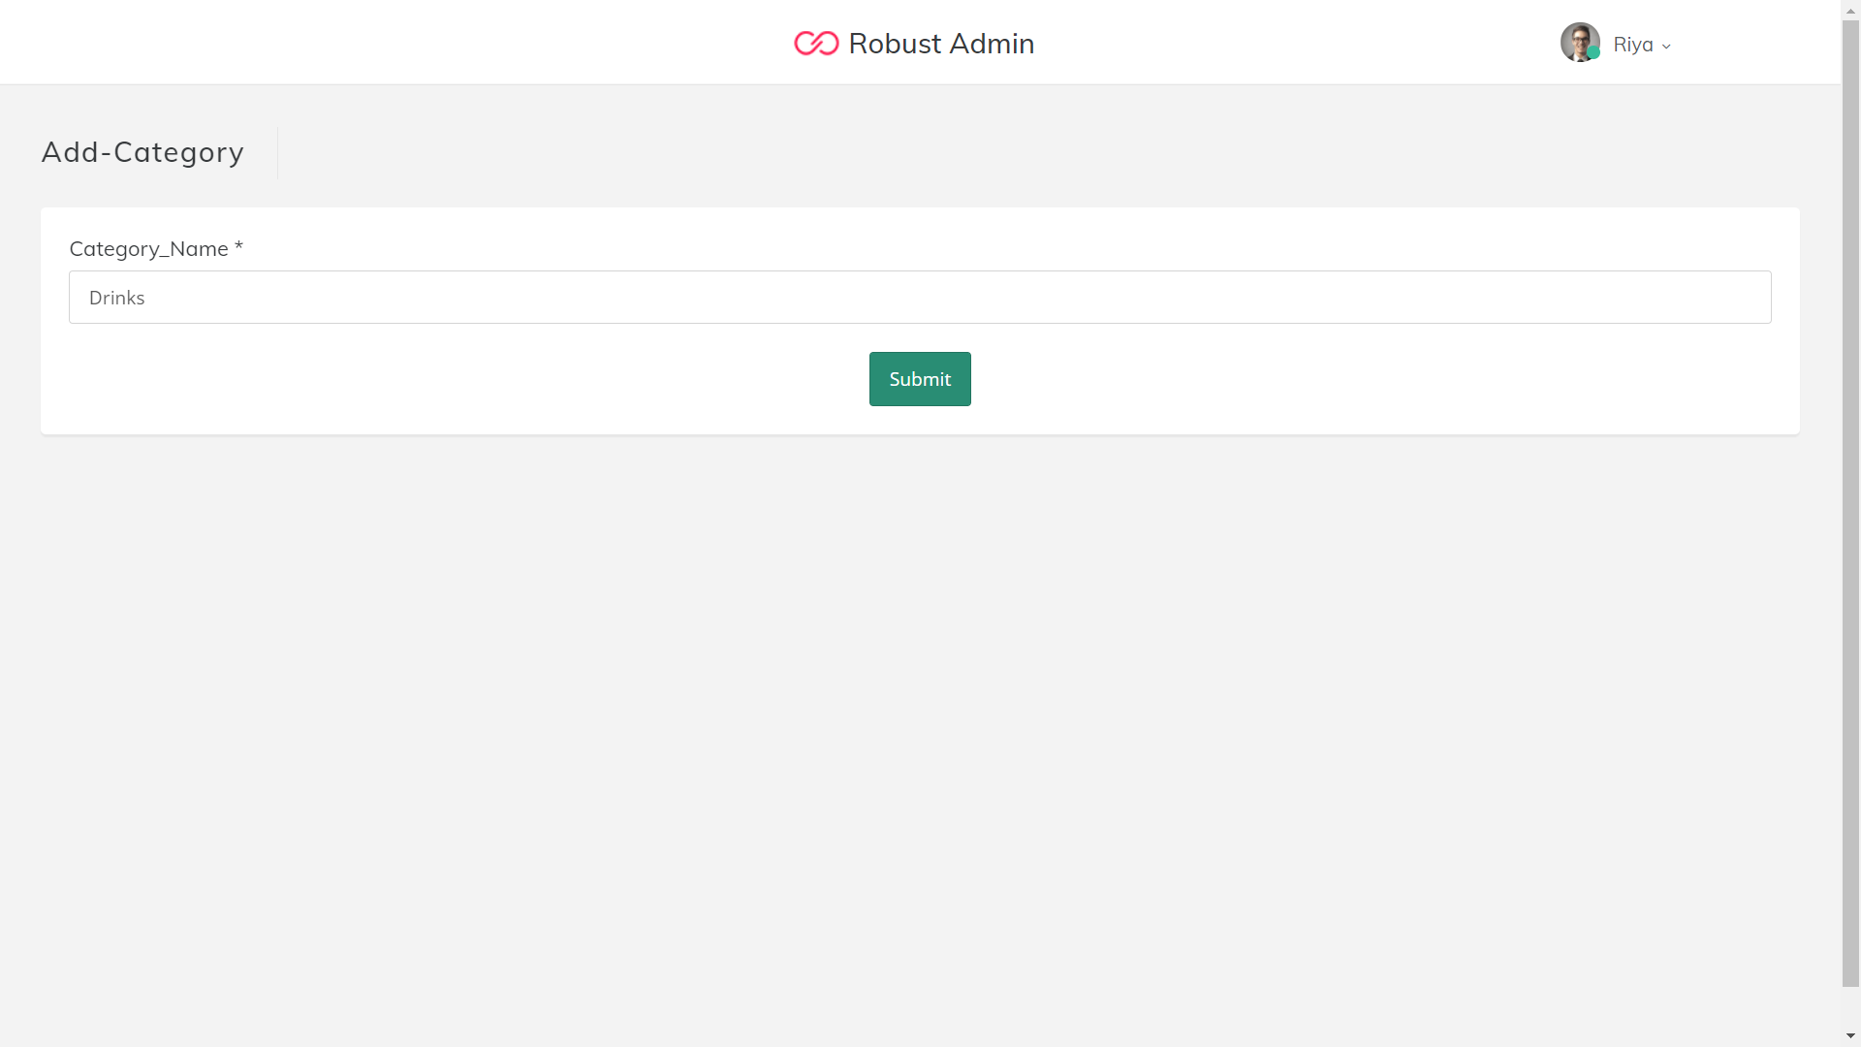

**Show-category**

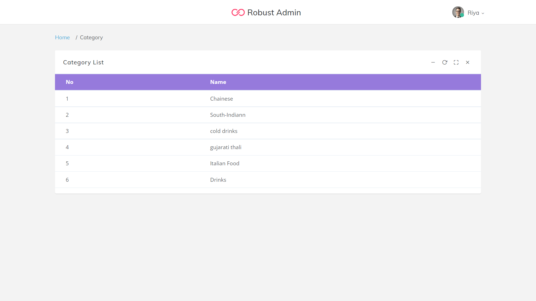

**Show Sales Reports**

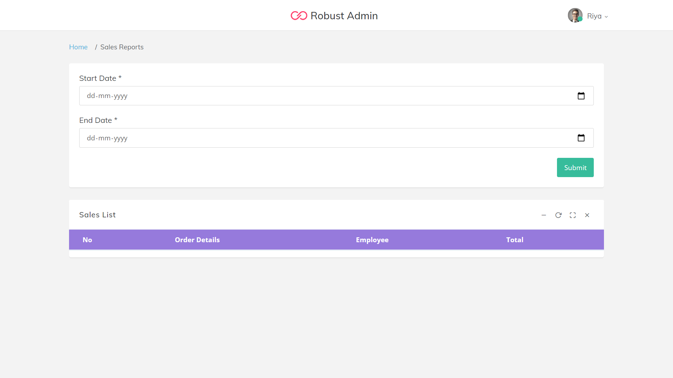

**Show purchase reports**

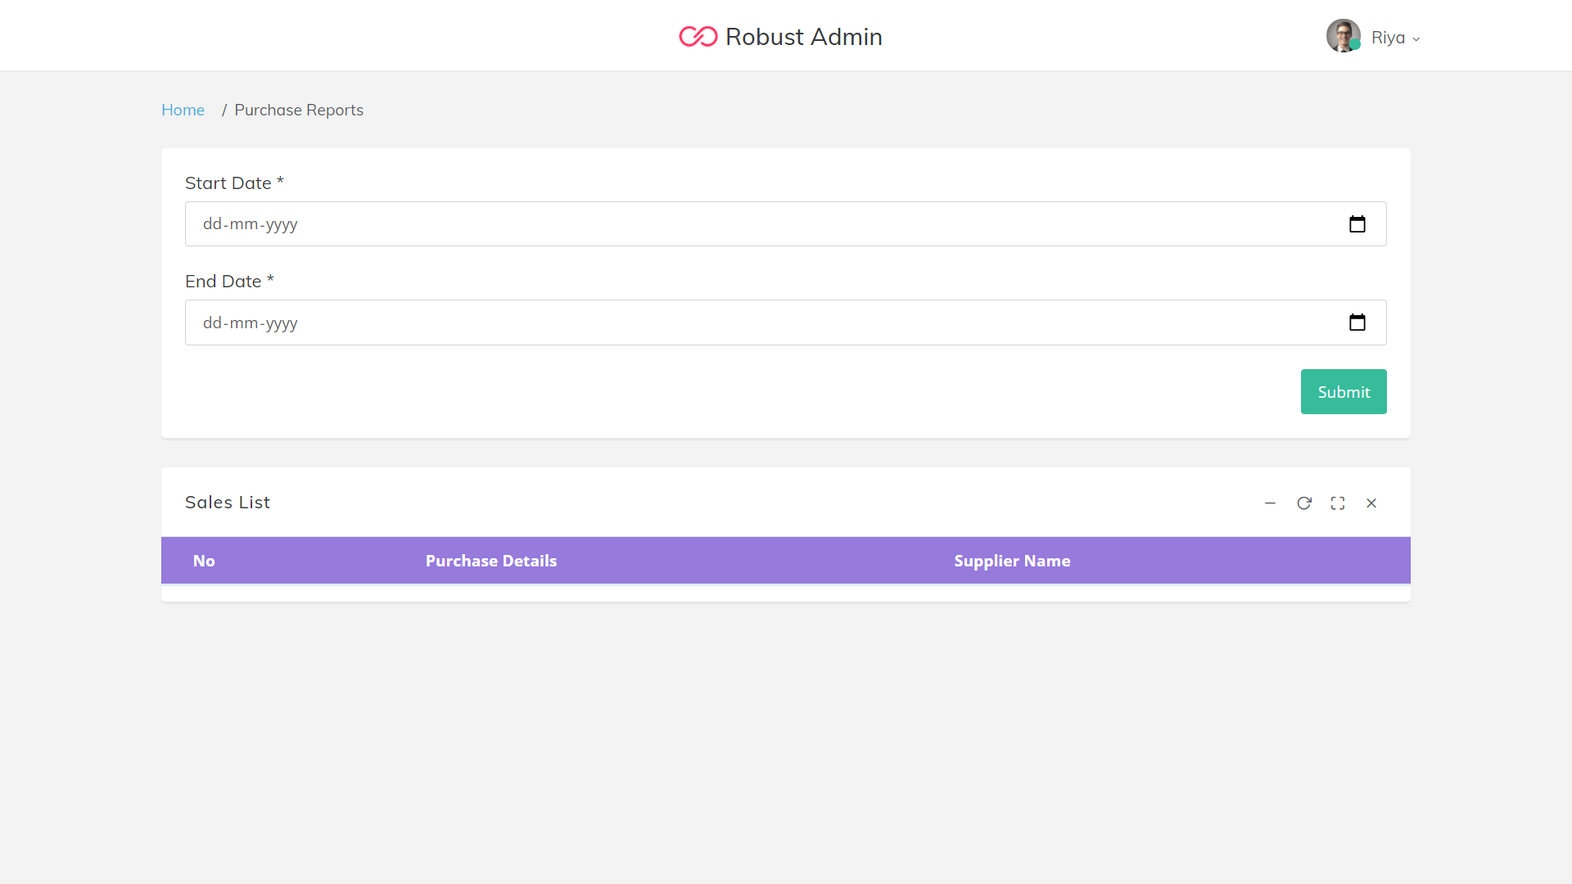

**Show user**

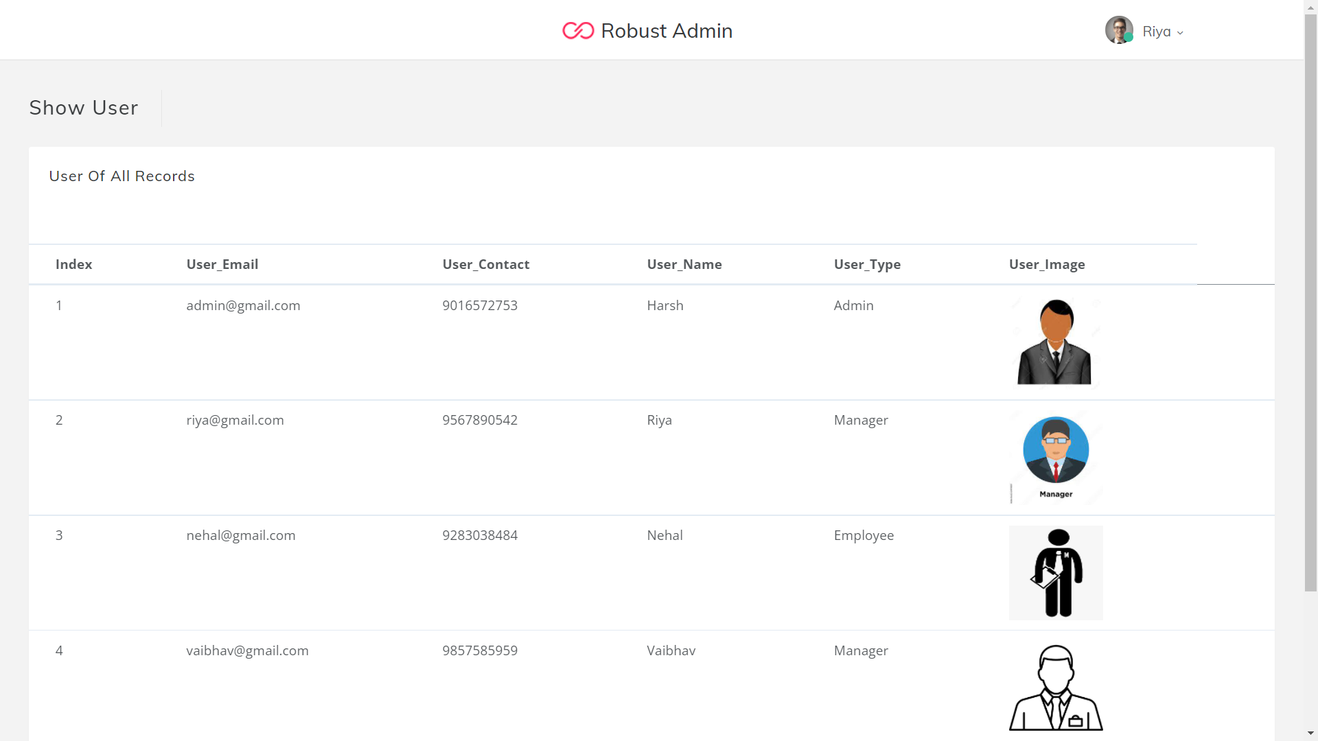

**Client(customer)**

**Dashboard**

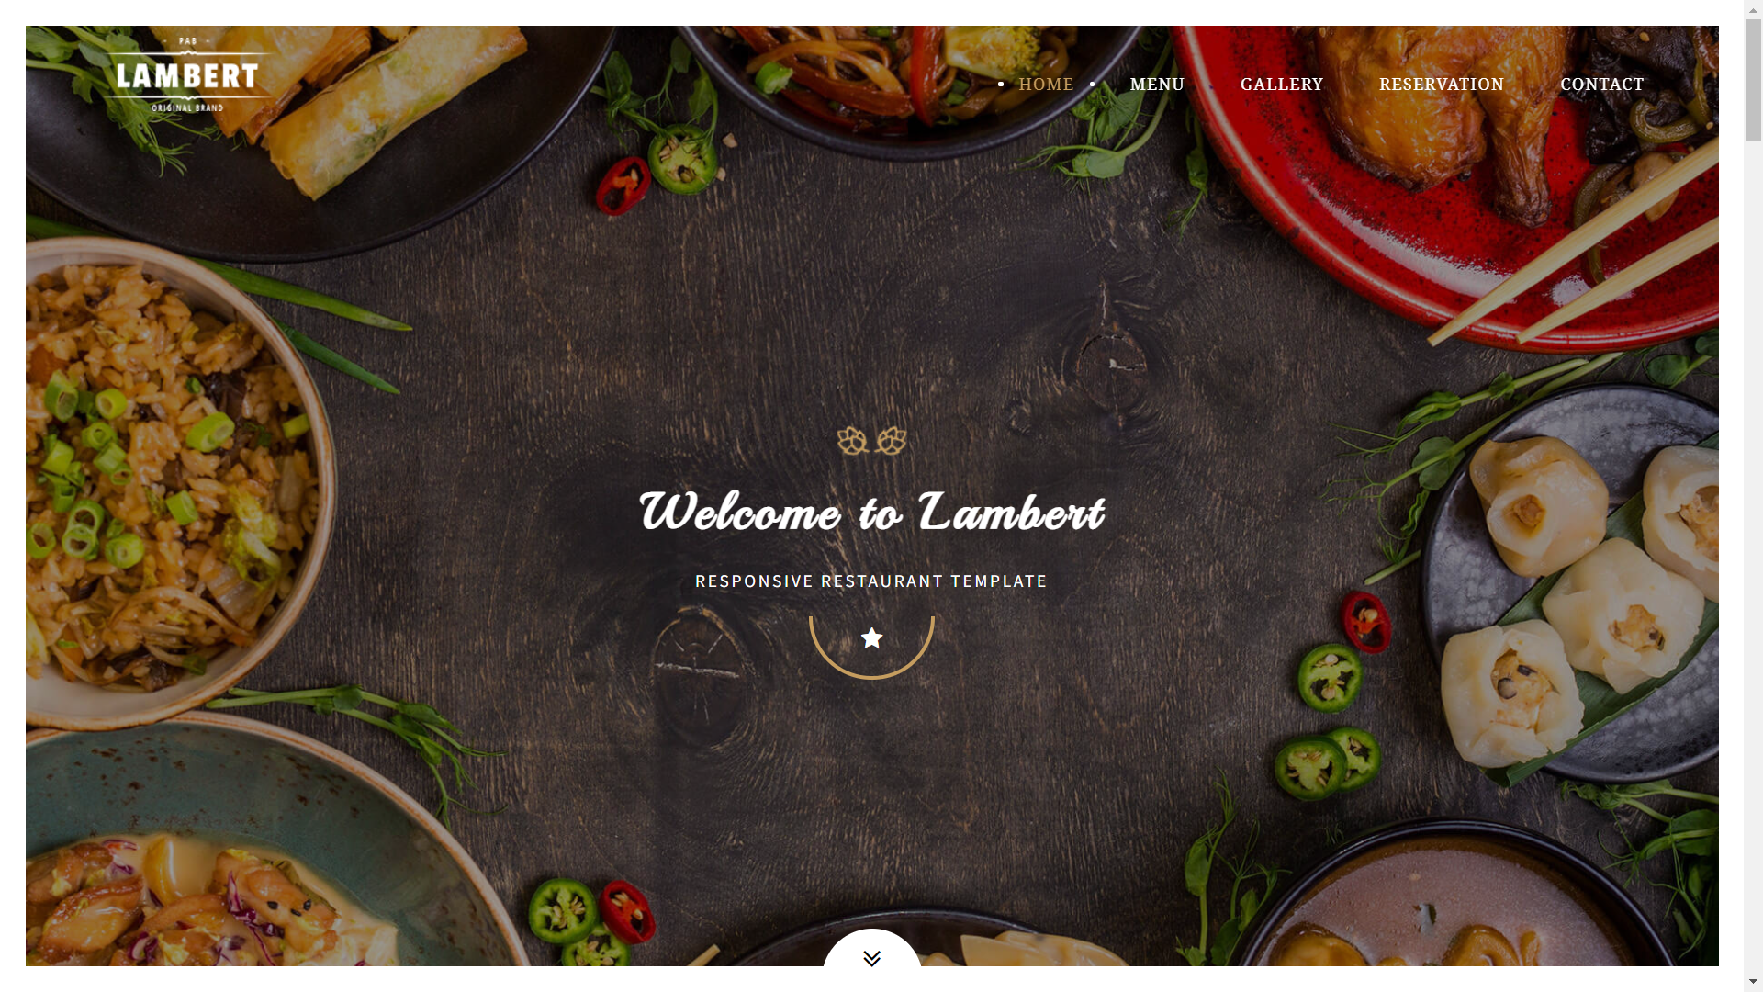

**Show Menu**

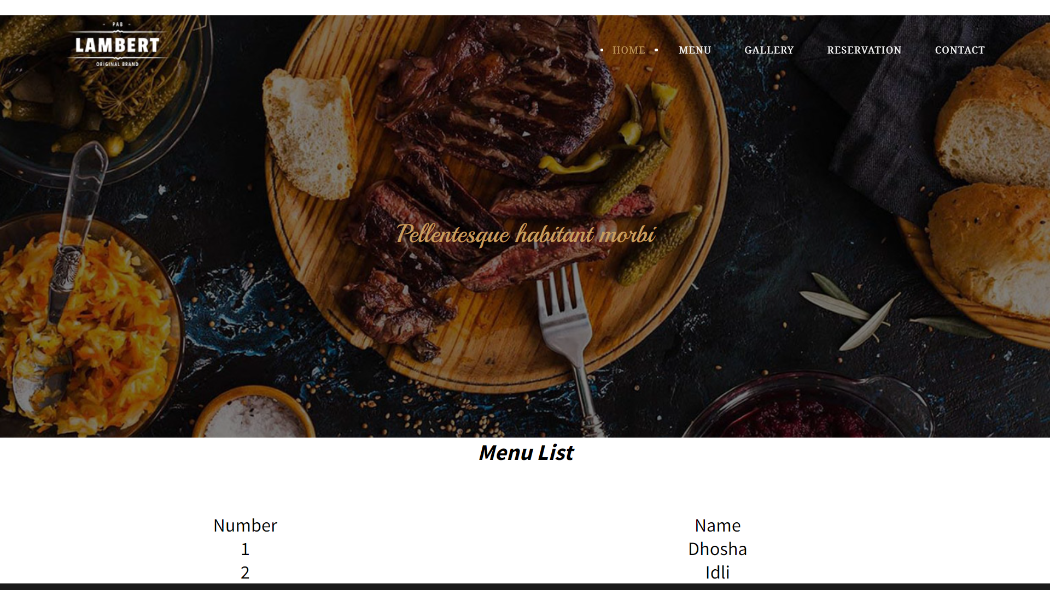

**Add Reservation**

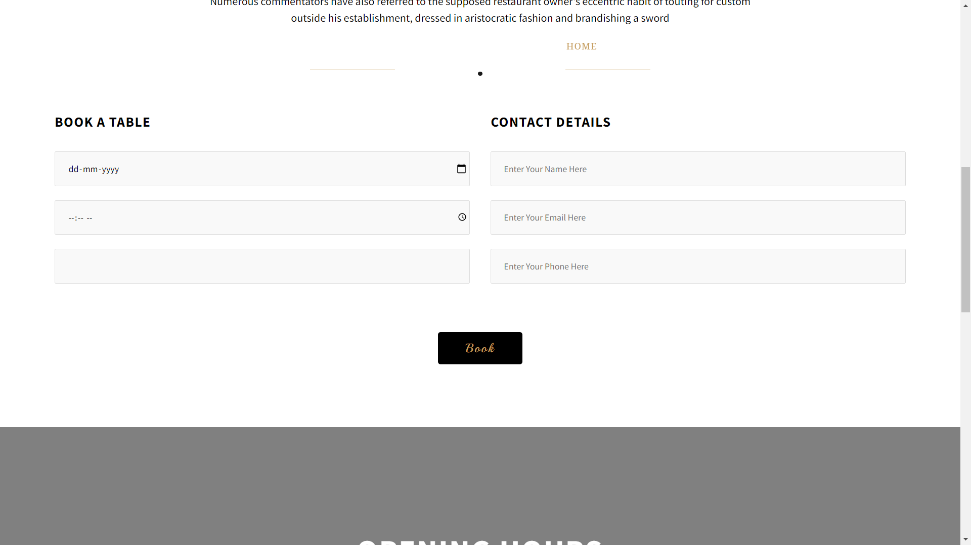

**7. Future Enhancement**

**In future payment module can add.**

**Customer can show time slot of the Restaurant.**

**8.** Bibliography

**Web References:**

[**https://stackoverflow.com/**](https://stackoverflow.com/)

**https://themeforest.net/**

**https**[**://ww**](http://www.codexworld.com/)**w.c**[**odexworld.com/**](http://www.codexworld.com/)

**https://developers.google.com/**